Q1. Create a frequency table and probability density table

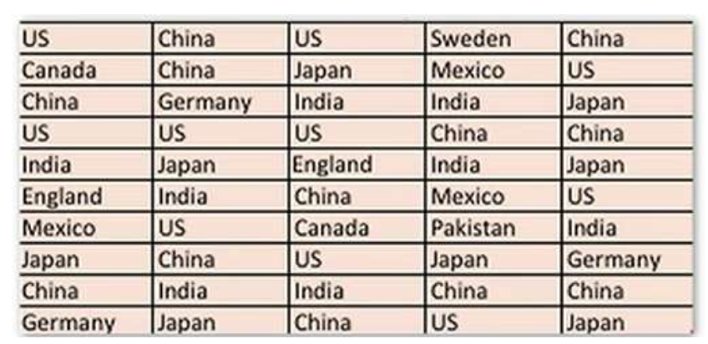

Q2. Create the histogram manually for the distribution of student ages. What bin size should you choose? Create the frequency table and relative frequency table

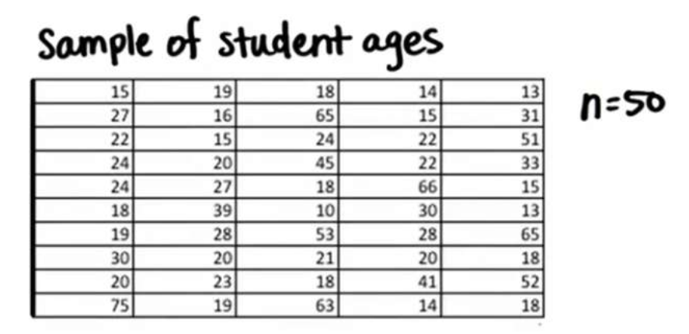

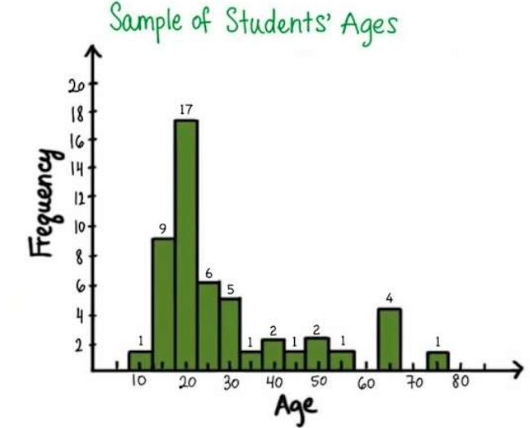

Q. What is the probability of randomly selecting a person having age between 10 years and 20 years?

Q. What is the probability of randomly selecting a person in the age 5yrs to 80 years?

Q. Plot the probability density curve for above histogram.

Q. Find the mean, median and mode age of students

Q. Is this distribution normal in shape? If not find out if it is right skewed or left skewed.

Q. Find the range and IQR for above distribution.

Q. Find the outliars for above distribution.

Q. What is the difference between a bar chart and a histogram?